KANCHARLA BRUNDARIKA
ENGLISH LANGUAGE ASSESSMENT- I (LA1)
Total: 50 MARKS

Section A: Grammar and Vocabulary (15 Marks)
1. Fill in the blanks with the correct form of the verb given in brackets. (5 x 1 = 5 marks)
(Test on tenses)
a) She usually _____goes_____ (go) for a walk in the evening.
b) I ____haven’t seen______ (not/see) him since last Monday.
c) They ___were watching _______ (watch) a movie when I called them.
d) He ____will complete______ (complete) the work tomorrow.
e) We ___should be studying _______ (study) for the test right now.

2. Choose the correct option to complete the sentences. (5 x 1 = 5 marks)
(Test on vocabulary and grammar usage)
a) The opposite of ‘polite’ is: (A)rude
A) rude B) generous C) kind D) clever
b) Choose the correct spelling: (B)definitely
A) definatly B) definitely C) definetely D) defenitely
c) A person who writes books is called a: B) author
A) editor B) author C) publisher D) poet
d) I ___ B) have finished _______ my homework before dinner.
A) finish B) have finished C) finished D) will finishing
e) Choose the correct preposition: The cat is hiding ____ A) on ______ the table.
A) on B) under C) over D) beside

3. Match the words with their meanings. (5 x 1 = 5 marks)
- Cautious ---- > (C) Careful A. Full of energy
- Swift ---- > (B)Quick B. Quick
- Drowsy ---- > (D) Sleepy C. Careful
- Vibrant---- > (A) Full of energy D. Sleepy
- Sincere ---- > (E)Honest E. Honest

Section B: Reading Comprehension (10 Marks)
Read the passage and answer the questions below:
Ravi loved visiting his grandmother’s village during the summer. The days were filled with playing in the fields, climbing mango trees, and helping his grandmother water the plants. One evening, while walking near the pond, he saw a turtle struggling in the mud. Without thinking, he rushed and helped it back into the water. That moment taught him the value of kindness towards all living creatures.
Questions:
- Where did Ravi go during summer? (1 mark)
Ravi went to his grandmother’s village during the summer.

- List two activities Ravi enjoyed in the village. (2 marks)
Playing in the fields and climbing mango trees.

- What did Ravi see near the pond? (1 mark)
He saw a turtle struggling in the mud.

- What did Ravi do when he saw the turtle? (2 marks)
He rushed and helped the turtle back into the water.

- What was the lesson Ravi learned? (2 marks)
He learned the value of kindness towards all living creatures.

- Give a suitable title to the passage. (1 mark)
Helping the Helpless

- Find a word in the passage that means “fighting hard” (1 mark)
Struggling

Section C: Writing Skills (15 Marks)

1. Picture Description (Choose any one): (5 marks)
Look at the picture below (a market on a busy weekend or a park).
Write 8-10 sentences describing what is happening in the picture from your own perspective.

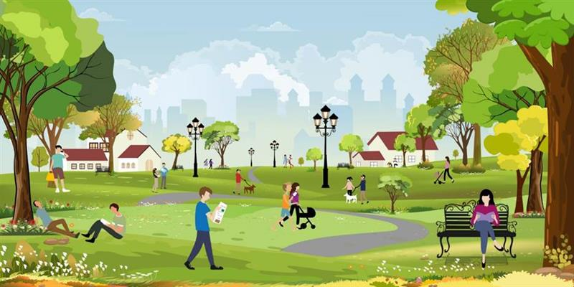
It looks like a peaceful park on a pleasant day. People are enjoying their time in different ways. I can see a man sitting on the grass and reading a book calmly. Another person is walking while reading something, which looks interesting. Children are playing and walking happily along the paths. A woman is pushing a baby stroller, enjoying a walk in the fresh air. Some people are sitting on benches, relaxing and spending quiet time. In the background, a few people are walking their dogs. The greenery, trees, and flowers make the park look beautiful and refreshing. Overall, it seems like a perfect place to relax and enjoy nature.

2. Informal Writing (100-200 words max) - (Choose any one): (10 marks)
- How is Technology changing the classroom?
- Why is Discipline important in life?
- My most embarrassing moment

How is Technology changing the classroom?
Modern technology is gradually transforming the traditional classroom into a completely different environment. Earlier, classrooms were lively with discussions and blackboard teaching. Now, they are becoming quieter, as students focus more on screens like tablets and laptops instead of books and notebooks. Smart boards are replacing traditional blackboards, making lessons more visual and interactive.
Online platforms and educational apps allow students to learn at their own pace and revisit lessons anytime. Assignments and tests can now be conducted online, saving time and effort. Communication between teachers and students has also improved through emails and learning management systems.
However, technology also brings some challenges. Students may get distracted by social media or misuse devices during class. Despite this, when used properly, technology makes learning more effective, interesting, and accessible for everyone.

